**1. Total Number of Unique Customers**

**Question: How many unique customers are present in the system?**

SELECT COUNT(DISTINCT customer_id) AS total_customers

FROM customer;



**2. Most Popular Flight Route**

**Question: Which flight route has the highest number of passengers?**

Select routes.origin_airport,routes.destination_airport,count(passengers_on_flights.customer_id) as total_passenger from passengers_on_flights

join routes

on

routes.route_id = passengers_on_flights.route_id

group by routes.origin_airport,routes.destination_airport

order by total_passenger desc

limit 3;

**3. Revenue per Flight Route**

**Question: What is the total revenue generated from ticket sales for each flight route?**

SELECT r.origin_airport, r.destination_airport, SUM(td.Price_per_ticket * td.no_of_tickets) AS total_revenue

FROM ticket_details td

JOIN routes r

ON

td.aircraft_id = r.aircraft_id

GROUP BY r.origin_airport, r.destination_airport

ORDER BY total_revenue DESC;

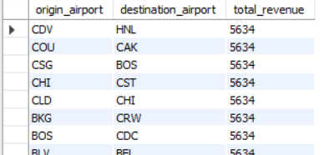

**4. Average Ticket Price per Route**

**Question: What is the average ticket price for each flight route?**

SELECT r.origin_airport, r.destination_airport, AVG(td.Price_per_ticket) AS avg_ticket_price

FROM ticket_details td

JOIN routes r

ON

td.aircraft_id = r.aircraft_id

GROUP BY r.origin_airport, r.destination_airport;

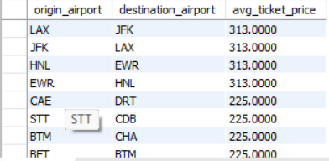

**5. Top 10 Customers by Number of Tickets Purchased**

**Question: Which customers have purchased the most tickets overall?**

SELECT c.first_name, c.last_name, SUM(td.no_of_tickets) AS total_tickets

FROM customer c

JOIN ticket_details td

ON

c.customer_id = td.customer_id

GROUP BY c.customer_id, c.first_name, c.last_name

ORDER BY total_tickets DESC

LIMIT 10;

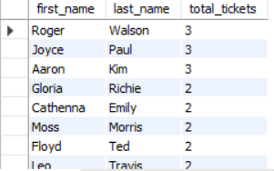

**6. Revenue Generated per Customer**

**Question: What is the total revenue generated from each customer?**

SELECT c.first_name, c.last_name, SUM(td.Price_per_ticket * td.no_of_tickets) AS total_revenue

FROM customer c

JOIN ticket_details td

ON

c.customer_id = td.customer_id

GROUP BY c.customer_id, c.first_name, c.last_name

ORDER BY total_revenue DESC;

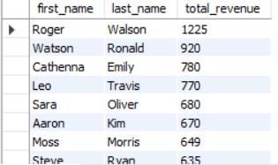

**7. Seat Class Preferences**

**Question: What is the distribution of seat classes chosen by passengers (economy, business, first class)?**

SELECT pf.class_id, COUNT(pf.customer_id) AS total_passengers

FROM passengers_on_flights pf

GROUP BY pf.class_id;

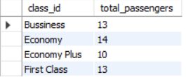

**8. Most Frequent Flyers**

**Question: Which customers have traveled the most on flights?**

SELECT c.first_name, c.last_name, COUNT(pf.flight_num) AS total_flights

FROM customer c

JOIN passengers_on_flights pf

ON

c.customer_id = pf.customer_id

GROUP BY c.customer_id, c.first_name, c.last_name

ORDER BY total_flights DESC

LIMIT 10;

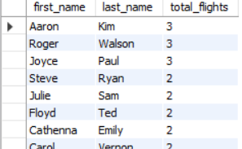

**9. Flight Occupancy by Route**

**Question: What is the average flight occupancy (number of passengers) for each route?**

SELECT r.origin_airport, r.destination_airport, COUNT(pf.customer_id) AS total_passengers

FROM passengers_on_flights pf

JOIN routes r ON pf.route_id = r.route_id

GROUP BY r.origin_airport, r.destination_airport;

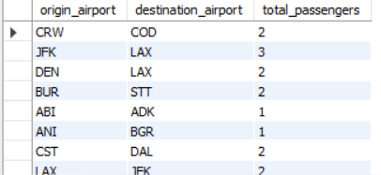

**10. Revenue by Seat Class**

**Question: How much revenue is generated from each seat class across all flights?**

SELECT pf.class_id, SUM(td.Price_per_ticket * td.no_of_tickets) AS total_revenue

FROM passengers_on_flights pf

JOIN ticket_details td

ON

pf.customer_id = td.customer_id AND pf.aircraft_id = td.aircraft_id

GROUP BY pf.class_id;

**11. Flight Distance and Ticket Price Correlation**

**Question: Is there a correlation between flight distance (in miles) and ticket price?**

SELECT r.distance_miles, AVG(td.Price_per_ticket) AS avg_ticket_price

FROM ticket_details td

JOIN routes r

ON

td.aircraft_id = r.aircraft_id

GROUP BY r.distance_miles

ORDER BY r.distance_miles;

**13. Top 5 Routes by Revenue**

**Question: Which 5 routes generate the highest revenue from ticket sales?**

SELECT r.origin_airport, r.destination_airport, SUM(td.Price_per_ticket * td.no_of_tickets) AS total_revenue

FROM ticket_details td

JOIN routes r

ON

td.aircraft_id = r.aircraft_id

GROUP BY r.origin_airport, r.destination_airport

ORDER BY total_revenue DESC

LIMIT 5;

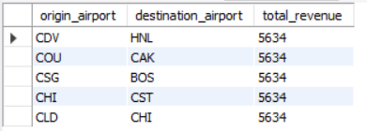

**14. Average Revenue per Flight**

**Question: What is the average revenue generated per flight for each aircraft?**

SELECT pf.aircraft_id, AVG(td.Price_per_ticket * td.no_of_tickets) AS avg_revenue

FROM passengers_on_flights pf

JOIN ticket_details td

ON

pf.customer_id = td.customer_id AND pf.aircraft_id = td.aircraft_id

GROUP BY pf.aircraft_id;

**15. Most Profitable Routes**

**Question: Which routes are the most profitable based on the number of passengers and ticket prices?**

SELECT r.origin_airport, r.destination_airport, SUM(td.Price_per_ticket * td.no_of_tickets) AS total_revenue, COUNT(pf.customer_id) AS total_passengers

FROM passengers_on_flights pf

JOIN ticket_details td

ON

pf.customer_id = td.customer_id AND pf.aircraft_id = td.aircraft_id

JOIN routes r

ON

pf.route_id = r.route_id

GROUP BY r.origin_airport, r.destination_airport

ORDER BY total_revenue DESC;

